Git revert

We use git revert after pushing the changes to remote

We have to give exact commit id which you want to revert

Consider below file staged commit done and pushed to remote

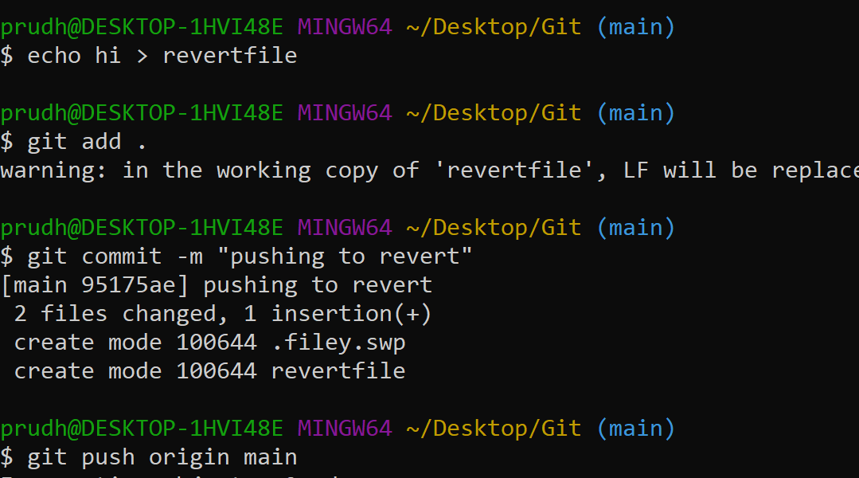

Check the log below

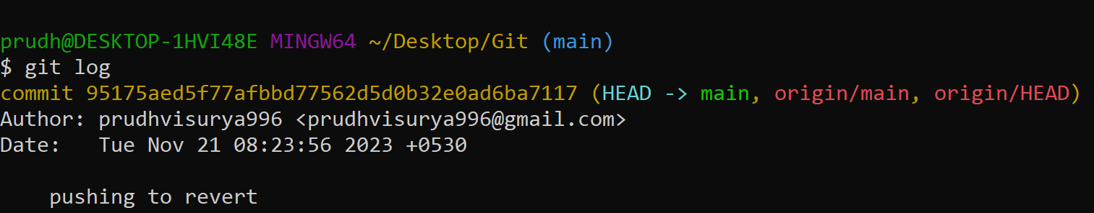

Pushing the revert is the commit I want to revert which is already pushed to remote

So I have to take the commit id 95175aed which is commit id

Git revert 95175aed

Now after this we have put some messgae like to indicate we are reverting

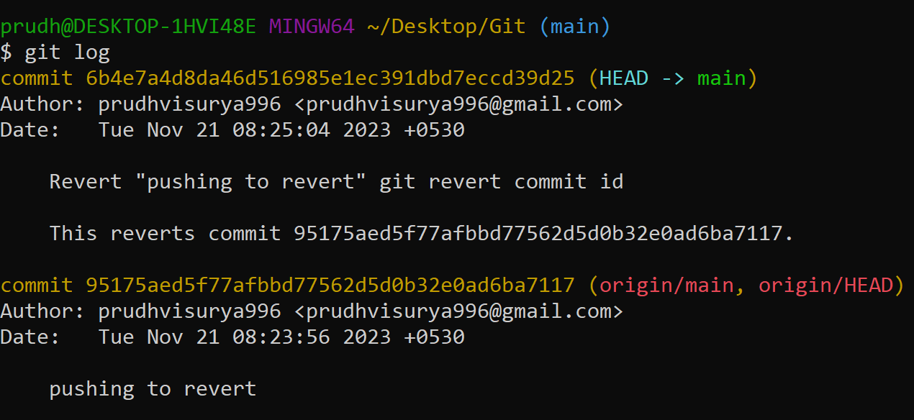

After hitting the above command you can see the commit id has been added to the log and once you the changes you can see that revert file wont be present in the remote

Git push origin main-----

This is how rrevet is done